## F-1 Train Value Calculations

### F-1.1 Rationale for this calculation

* In the DMFEA, items 12.1 and 12.2 rate an inappropriate train value as a high RPN concern (RPN = 64). This is because the implementation of rider propulsion is the primary design improvement from the current TrailRider, and failure to do so effectively would greatly diminish the value of the device.
* Requirement 7.3 states that the time to reach top speed for the device is less than 5 seconds, which is largely impacted by the train value.
* Requirement 7.4 states that the top speed of the device is greater than 1.0 m/s, which is also largely impacted by the train value.

### F-1.2 Deriving the governing equations

The main tradeoff that affects the train value selection is the top speed of the device against its initial acceleration.

The governing equation for a train value based on top speed is derived from the diagram below.

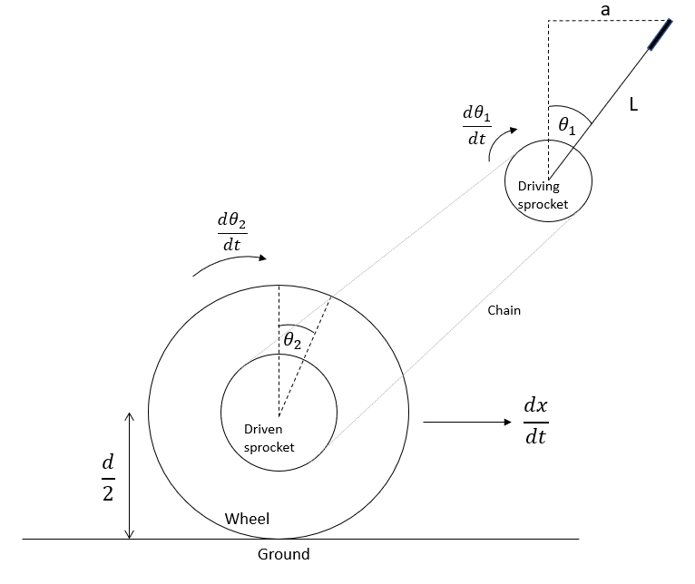

*Assumptions*

* The motion of the rider’s hand is linear (a)
* The power delivered in each stroke of the lever at top speed is sufficient to overcome rolling resistance and maintain constant velocity of the pulleys
* There is no slipping between the ground and the tire
* Efficiency of power transmission between the two sprockets is 100% (conservative estimates are applied elsewhere in this calculation so using less efficiency is unnecessary)

Now the following equations are obtained

|  |  |
| --- | --- |
| $θ_{1}=sin^{-1}(a/L)$ | (1) |
| $\frac{d θ_{1}}{dt}=\frac{d}{dt}(sin^{-1}(a/L))=(1-(a^{2}/L^{2 }))^{-1/2}*(L)^{-1}*\frac{da}{dt}$ | (1.1) |
| $\frac{d θ_{2}}{dt}=e*\frac{d θ_{1}}{dt}$ | (2) |
| $H_{rider}=F_{hand}*v_{hand} =F*\frac{da}{dt}$ | (3) |
| $\frac{dx}{dt}=\frac{{d θ}_{1}}{dt}*0.5d$ | (4) |
| $e =\frac{dx}{dt}*(0.5Hd)^{-1}*LF_{H}\sqrt{1-a^{2}/L^{2}}$ | (5) |

The governing equation for a train value based on the initial acceleration is derived based on the free body diagram shown below.

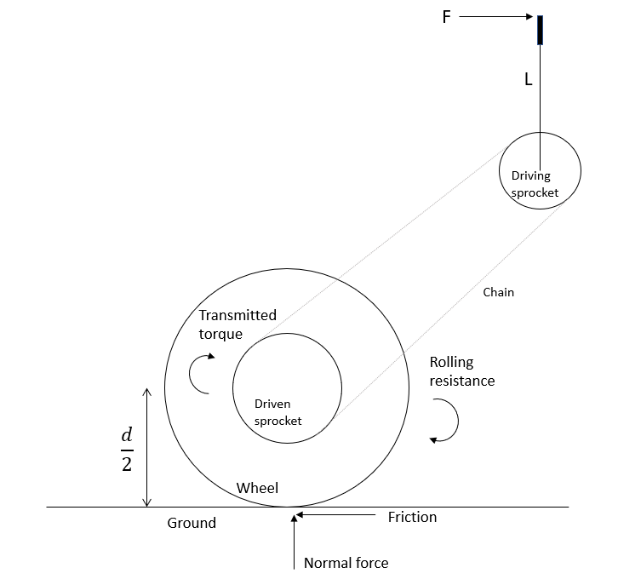

*Assumptions*

* The input torque is assumed to be constant throughout the entire powerstroke
* There is no slipping between the ground and the tire
* The efficiency of power transmission between sprockets is 100%

Now the following equations are obtained

|  |  |
| --- | --- |
| $T_{in}=F_{H}L$ | (6) |
| $T_{out}=(1/e)T_{in}$ | (7) |
| $a={(2T}_{out} /d -F_{RR})/m$ | (8) |
| $Δt =(v_{f}-v_{i})/a = \frac{dx}{dt}/a$ | (9) |
| $e=2F_{H}LΔt/[d(m\frac{dx}{dt}+Δt F_{RR})]$ | (10) |

Equation 5 and Equation 10 give two relationships for the train value based on two different parameters: top speed of the device ($\frac{dx}{dt}$) and the time to reach top speed from rest ($Δt$).

### F-1.3 Estimating Parameters

The next step is to estimate the values of the known parameters, which is done in the table below.

|  |  |  |  |
| --- | --- | --- | --- |
| **Parameter** | **Value** | **Units** | **Source** |
| d (wheel diameter) | 0.66 | m | 26” wheels are chosen for our device. |
| a (arm extension) | 0.4 | m | Estimate based on comfortable arm extension. |
| L (lever length) | 0.5 | m | Estimate based on other lever drive systems. |
| FRR | 9 | N | See *Note 1* below, also see Limitations Section |
| H (power input) | 30 | W | See *Note 2* below, also see Limitations Section |
| m | 76 | kg | Estimated average mass of rider and device |

*Note 1*: The rolling resistance of a manual wheelchair with their experimental set up is at most 7.7 N [1]. 9 N is used for this calculation as a conservative estimate.

*Note 2:* The average power output of a person through pedals over ninety minutes is approximately 150W [2]. As a conservative estimate, it is assumed that arms can produce 20% of the power of legs while pedalling. Therefore, the input power is 30W.

### F-1.4 Calculating the train value

Equations 5 and 10 were inputted into a spreadsheet and the remaining parameters were manually iterated until a reasonable combination was achieved. The first train value calculation iteration is shown below.

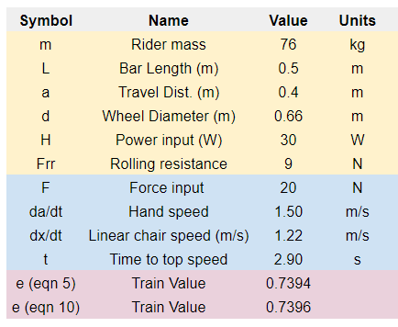

As seen, a train value of approximately 0.74 is obtained. Given that a 17 tooth pulley is chosen for the driving sprocket (see Section F-2), this train value requires a 23 tooth driven sprocket. 24 tooth sprockets are far more common in bike cassettes, so a train value of 17/24 = 0.71 is used instead. The parameters in the spreadsheet were adjusted to achieve this value as shown below.

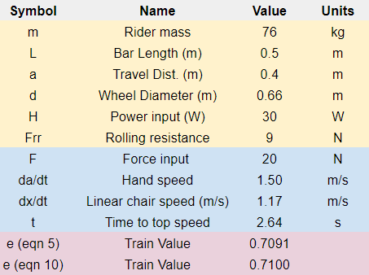

The final choice of parameters based on this process are summarized in the table below.

|  |  |  |  |
| --- | --- | --- | --- |
| **Parameter** | **Value** | **Units** | **Justification** |
| dx/dt (top speed at 30W input power) | 1.17 | m/s | Requirement 7.4 states that this value should be greater than 1 m/s. |
| FH (rider hand force) | 20 | N | Chosen in tandem with da/dt based on reasonable values that achieve the calculated power input. |
| da/dt (rider hand speed) | 1.5 | m/s | See the field above. |
| Δt (time to top speed) | 2.63 | s | Requirement 7.3 states that this value should be less than 5 seconds. |
| e (train value) | 0.71 | n/a | See the process above. |

Thus, 0.71 is chosen as the default train value.

### F-1.5 Variable train value option

This work does not yet address item 12.2 in the DFMEA, which states that the specified train value will not be suitable for all users due to differing physical capabilities.

The ‘action item’ for this failure mode is to use a cassette with various sprockets that allow for different train values for users upon purchase of the device. The cassette includes 28-tooth, 24-tooth and 20-tooth sprockets. The figures below show the performance of the device based on these train values, with increased power input at 40W and decreased power output at 20W. Note that the values at 20W input are near the boundaries for Requirement 7.3 and 7.4 (minimum 1 m/s top speed and maximum of 5 seconds to reach top speed).

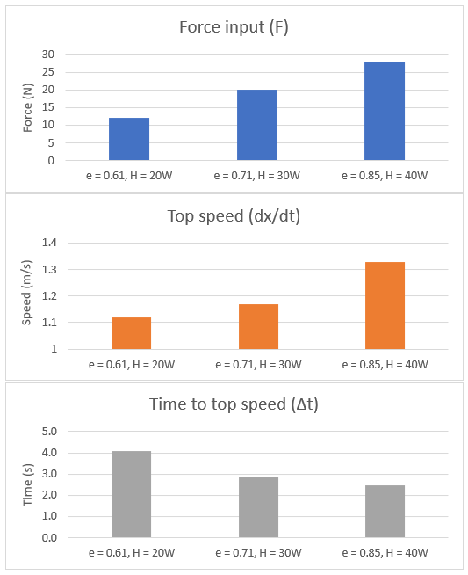

#### F-1.6 Limitations

These calculations are intended to be an approximation for an appropriate train value. It is not possible to confidently determine the best value without physically testing the device. The most likely sources of error in these calculations are summarized below.

*FRR, Rolling Resistance*

|  |  |
| --- | --- |
| Sources of Error | This value was taken from literature for a standard manual wheelchair [1]. Our device has mountain bike tires, a different weight distribution, an all-terrain caster and other key differences. Additionally, the rolling resistance force will depend on the mass of the rider, which is held constant in these calculations. A more accurate calculation would estimate the coefficient of rolling resistance for the device and scale the resistive force according to rider mass. |
| Effect on Analysis | Incorrectly approximating this value will only result in minor performance variations. As seen, the rolling resistance can be increased to 35 N (a 290% increase) before the requirements for speed and acceleration are not met. It is highly unlikely that the rolling resistance is that high. Regardless, the optimal nominal train value will still be achievable with off-the-shelf sprockets. |
| Proposed Mitigation | Rolling resistance is specific to the device and situation and cannot be accurately determined through research. The best mitigation is to build a physical prototype and test the rolling resistance under a variety of conditions (e.g. rider mass, tire pressure, bearing quality). |

*H, Power Input*

|  |  |
| --- | --- |
| Sources of Error | This value was approximated based on the power of legs during pedalling. The value of 20% used to relate leg strength to arm strength may be too conservative (on average men can bench press 70% of the weight they squat [3]). |
| Effect on Analysis | The effect of variations in input power is addressed in Section F-1.5. 20W is near the minimum power input that would meet device requirements. An increase in power input simply increases the optimal train value. |
| Proposed Mitigation | More thorough research, including speaking with experts in the field, may be sufficient to obtain more accurate power input values. Alternatively, a prototype drive-train could be assembled and the power input of various users could be measured directly. This would also inform the range of train values discussed in Section F-1.5. |

*m, Rider and Chair Mass*

|  |  |
| --- | --- |
| Sources of Error | This value is held constant throughout the analysis. Of course, riders will have varying masses. |
| Effect on Analysis | The greatest effect of mass variation will likely occur indirectly through variations in rolling resistance and power input, which are discussed above. The direct influence of mass in Equation 10 will only result in minor performance changes. Without considering changes in power input or rolling resistance, the rider mass can be increased to 204 kg before the speed and acceleration requirements are not meet. |
| Proposed Mitigation | As discussed above, the impact of mass on rolling resistance is important to characterize, which can be done by determining the coefficient of rolling resistance for the device. |

### F-1.7 Responsible Personnel

The following personnel are responsible for the calculations in Section F-1.

|  |  |  |  |  |
| --- | --- | --- | --- | --- |
| Authored by |  | Carson Hopkins |  |  |
|  |  | Name |  | Signature |
| Verified by |  | Julia Zhuravleva |  |  |
|  |  | Name |  | Signature |

## F-2 Chain and Sprocket Calculations

### F-2.1 Rationale for this Calculation

The need for wear and fatigue calculations for the chain and sprockets is informed by the DMFEA. The table below summarizes the specific DMFEA items that are addressed and the process for doing so.

|  |  |  |
| --- | --- | --- |
| **DFMEA item No.** | **Failure Type** | **Analysis for mitigation** |
| 9.1 | Wear | Follow the process for mitigating roller wear outlined in Shigley’s [4]. For an accurate analysis from this method, the following criteria must be met. ${(Life expectancy)}_{allowable} =15000 hr$  * Train value is less than 6:1 * Single strand chain * ANSI proportions * Service factor of unity * 100 pitches in length * Recommended lubrication implemented * Elongation maximum of 3 percent * Parallel Shafts |
| 9.2 | Roller fatigue | * Calculate Hallowable * Using Hallowable and desired safety factor, select ANSI driving sprocket * Recalculate safety factor to verify that it meets specifications |
| 0.3 | Link-plate fatigue | Same as the field above |

### F-2.2 Governing Equations

Sprocket life expectancy:

$t_{allowable }=15000hrs$

$(trip per lifetime)=(rides / weekend day) *(weekend days / month)*(usable months / year)*(years / lifetime)$

$t_{design} =(trip per lifetime)*t_{sustained}=(trip per lifetime) *x_{trail} / v_{desired}$

$SF=t_{allowable} / t_{design }$

Sprocket stress:

$F_{driven}={fF}_{normal}=f(m_{person}+m_{chair})g / 2$

$H_{out}=F_{driven}v_{desired}$

$H_{in}=fn(t_{sustained})=fn(x_{trail} / v_{desired})$

$H_{nom}=H_{in}$

$n_{d}=(loss of function parameter) / (maximum allowable parameter) =H_{out} / H_{a}$

$H_{d}=H_{nom}K_{s}n_{d}$

$SF=\frac{H_{a}}{H_{d}}=\frac{H_{a}}{H_{nom}K_{s}n_{d}}=\frac{H_{a}}{H_{nom}K_{s}\frac{Hout}{Ha}}=\frac{{H_{a}}^{2}}{H_{nom}K_{s}H_{out}}$

$H_{a}=\sqrt{SF*H_{nom}{*K}_{s}*H_{out}}$

$H_{a}=(Tabulated power)*(Correction factor)*(Strand correction factor)=H_{tab}K_{1}K_{2}$

$H_{tab}=fn(≤15000hr use,min(ω_{driving}=ω_{driven}/e,ω_{driven}=v_{desired} / {(πd}_{wheel})),ANSI number)$

### F-2.3 Summary of Known Values

|  |  |  |  |  |
| --- | --- | --- | --- | --- |
| **Description** | **Symbol** | **Value** | **Units** | **Source** |
| Distance of Stanley Park trail | x_trail | 6500 | m | [5] |
| Mass of device | m_chair | 20.4 | kg | [6] |
| Mass of rider | m_person | 76 | kg | [7] |
| Wheel diameter | d_wheel | 0.66 | m | 26” wheels selected |
| Desired velocity | v_desired | 1.00 | m/s | Requirement 7.4 |
| Service factor | K_s | 1 |  | Estimated based on expected light shock |
| Dynamic friction coefficient | f | 0.01 |  | [8] |
| Stress Safety Factor | SF | 3 |  | Requirement 2.6 |
| Life Expectancy Safety Factor | SF | 2 |  | Requirement 2.7 |
| Rides per day |  | 1 |  | Client Q&A (09/11/2019 at 3:00PM) |
| Weekend days per month |  | 8 |  | 4 weeks/month |
| Usable months per year |  | 4 |  | Client Q&A (09/11/2019 at 3:00PM) |
| Years / lifetime |  | 10 |  | Requirement 6.1 |
| Gravity | g | 9.81 | m/(s^2) | Common knowledge |
| Train value | e | 0.71 |  | Section F-1.4 |

### F-2.4 Calculations

Sprocket life:

$(trip per lifetime)=(rides / weekend day) *(weekend days / month)*(usable months / year)*(years / lifetime)$

$(trip per lifetime)=1*8*4*10=320$ $t_{design} =(trip per lifetime)*t_{sustained}=(trip per lifetime) *x_{trail} / v_{desired} =320*6500/1=577.78hr$

Sprocket stress:

$F_{driven}={fF}_{normal}=f(m_{person}+m_{chair})g / 2 =0.008(20.41+83.8)9.81/2 =4.1N$

$ω_{driven}=v_{desired} / {(πd}_{wheel})=1/(π0.66)=0.48 rot/s$

$H_{out}=F_{driven}v_{desired}=4.1W$

$H_{in}=0.3*{fn}_{leg}(t_{sustained})=0.3*{fn}_{leg}(x_{trail} / v_{desired})={0.3*fn}_{leg}(6500/1=108.33min)=0.3*100W=30W$

$H_{nom}=H_{in}=30W$

$H_{a}=\sqrt{SF*H_{nom}{*K}_{s}*H_{out}}=\sqrt{3*30*1*4.1}=13.32W=0.02HP$

Next, the driving sprocket is chosen to be 17-teeth and the chain is chosen to be single strand such that:

$K_{1}=1$

$K_{2}=1$

$ω_{driven}=v_{desired} / {(πd}_{wheel})=1/(π0.66)=0.48 rot/s=28.92rpm$

$ω_{driving}=ω_{driven}/e=28.92/0.7=41.31rpm$

$H_{tab}=fn(≤15000hr use,min(ω_{driven},ω_{driving}),ANSI number)$

$H_{tab}=fn(577.78hr,28.92rpm,40 ANSI number)=0.03 HP$

$H_{a}=H_{tab}K_{1}K_{2}=0.03*1*1=0.03HP=21.28W$

Stress safety factor verification:

$SF=\frac{{H_{a}}^{2}}{H_{nom}K_{s}H_{out}}=\frac{21.28{}^{2}}{30*1*4.1}=7.66≥3$

Life expectancy safety factor verification:

$SF=t_{allowable} / t_{design }=15000/577.78=25.96≥2$

### F-2.5 Conclusion

* Requirement 2.6 is met, as the stress safety factor is 7.7
* Requirement 2.7 is met, as the life-expectancy safety factor is 26
* The RPN of the DMFEA items identified in Section F-2.1 are reduced below the level of concern

### F-2.6 Responsible Personnel

The following personnel are responsible for the calculations in Section F-2.

|  |  |  |  |  |
| --- | --- | --- | --- | --- |
| Authored by |  | Ratthamnoon Prakitpong |  |  |
|  |  | Name |  | Signature |
| Verified by |  | Carson Hopkins |  |  |
|  |  | Name |  | Signature |

## F-3 Tipping Calculations

### F-3.1 Tipping in the roll direction

Rationale for this calculation:

* Item 11.1 in the DMFEA rates tipping in the roll direction as a high RPN concern (54) until further explored
* Requirement 2.3 states that the chair is able to roll over an obstacle of at least 30cm with one wheel without tipping

The governing equation for roll tipping is derived from the FBD below

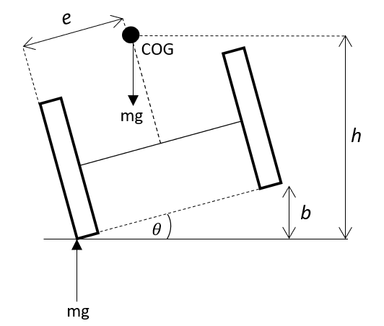

* The wheelchair tips when center of mass is vertical above the point of contact.
* This occurs when (1), where
  + e is the horizontal distance from the contact wheel to the center of mass
  + h is the vertical distance from the ground to the center of mass
  + θ is the roll angle from the ground
* The angle of the chair over a bump of size b is also a function of the width of the chair, 2e. $tanθ=b/2e$ (2)
* Combining equations (1) and (2), it follows that $2e^{2}/\sqrt{h^{2}-e^{2 }}=b$
* Given that the wheel diameter is 26” (66cm) and the center of mass is estimated to sit at 0.75*66 = 49.5cm above the ground, h = 49.5cm.
* Plugging in the previously stated values for b and h and using an equation solver gives e = 0.26m.
* Assuming that the COG is in the center of the width of the chair, 0.26*2 = **0.54m** is the minimum wheel width of our device to meet the established tipping requirement.
* 0.7m is chosen for comfort. This calculation also shows that tipping - a high severity failure mode - is of sufficiently low likelihood.
* In summary, Requirement 2.3 is met and the RPN of DFMEA item 11.1 has been reduced from 54 to 18.

### F-3.2 Tipping in the pitch direction

Rationale for this calculation:

* Item 11.2 in the DMFEA rates tipping in the pitch direction as a high RPN concern (63) until further explored
* Requirement 2.4 states that the chair is able to roll over an obstacle of at least 30cm with one wheel without tipping

The governing equation for pitch tipping is derived from the FBD below

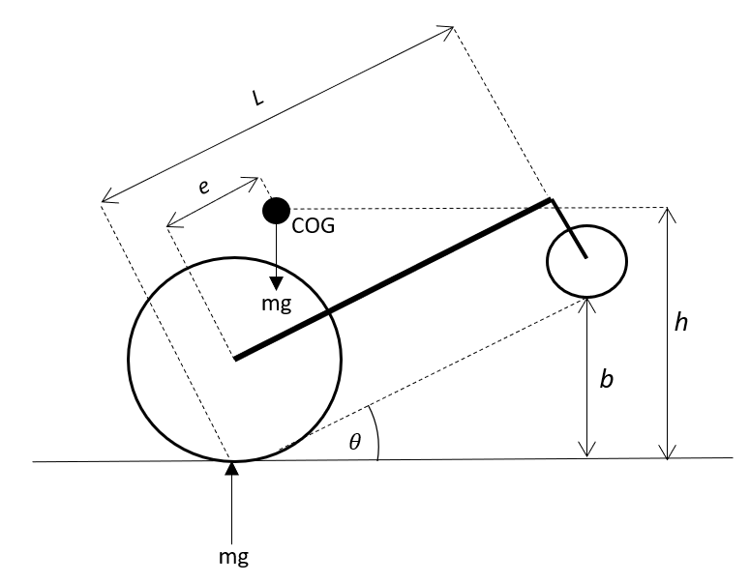

* The wheelchair tips when center of mass is vertical above the point of contact.
* This occurs when (1), where
  + e is the horizontal distance from the contact wheel to the center of mass
  + h is the vertical distance from the ground to the center of mass
  + θ is the roll angle from the ground
* The angle of the chair θ over a bump size *b* is a function of the length L of the chair, $b=Ltanθ$
* Based on the geometry of the chair and the anatomy of a person, assume that e = 0.2m.
* With h = 0.495m as above, θ = 24° based on equation (1)
* With b = 0.3m, L = 0.70m based on equation (2)
* Therefore, the minimum length of the chair to meet the tipping requirement is **0.70m**

The following personnel are responsible for the calculations in Section F-3.

|  |  |  |  |  |
| --- | --- | --- | --- | --- |
| Authored by |  | Carson Hopkins |  |  |
|  |  | Name |  | Signature |
| Verified by |  | Julia Zhuravleva |  |  |
|  |  | Name |  | Signature |

## F-4 Bearing Calculations

### F-4.1 Rationale for this Calculation

The rationale for this calculation is to specify the bearings holding the driven shafts to the frame. The figure below shows the shaft, its components, and the dimensions considered.

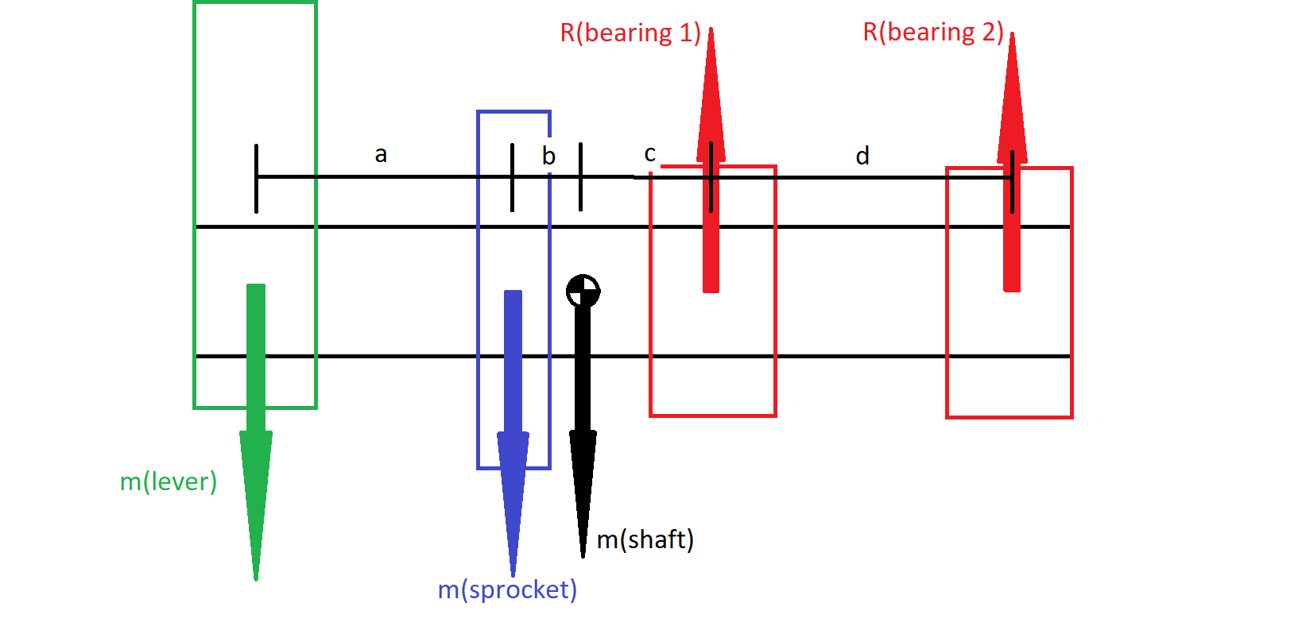

The analysis is divided into static and dynamic loading. For static, only the weights of the components are taken into account. For dynamics, the added force from the user torque input is added to the static forces. Note, the sprocket is approximated as a spur gear with 20° pressure angle.

### F-4.2 Static Analysis

Moments are taken about bearing 1 to solve for reaction forces of bearing 2. And sum of forces are taken to solve for reaction forces of bearing 1. These reaction forces were used as the minimum static radial load our selected bearing must withhold. The governing equations are below, where “m” is the gravitational force from the mass of each component in [Newtons]:

$ΣM_{B1}={0 = m}_{lever}×(a+b+c) + m_{sprocket}×(b+c) + m_{shaft}×(c) + R_{B2}×(d)$

$ΣF_{y} = {0 = -m}_{lever} - m_{sprocket} - m_{shaft} + R_{B1} + R_{B2}$

With:

* a = 80 mm
* b = 13.5 mm
* c = 31.5 mm
* d = 60 mm
* Component weights taken from the parts catalogues

Our results for static loading show:

* RB1 = 30 N
* RB2 = -16.7 N

### F-4.3 Dynamic Analysis

For dynamic loading we add the 6.93 Nm torque input from user derived from sprocket calculations, estimate the sprocket as spur gear, and add its resulting force directly to msprocket. Note that the “spur gear” resulting force may not be in the same vertically downward direction as msprocket, but we add them this way for a conservative approach. With these assumptions we find the additional radial load due to user torque input. The governing equations are:

$W_{t}=\frac{T_{user input}}{r_{sprocket}}$

$W_{r}=W_{t}tan(20°)$

$W= \sqrt{ W_{t}^{2} + W_{r}^{2}}$

With:

* User torque input of 6.93 Nm
* Sprocket outer diameter of 37.8 mm, taken from parts catalogue

We get a resulting force W = 460.9 N

Similar to static analysis, moments are taken about bearing 1 to solve for reaction forces of bearing 2. And sum of forces are taken to solve for reaction forces of bearing 1. These reaction forces were used as the minimum dynamic radial load our selected bearing must withhold. The governing equations are below, “m” is the mass x gravity of each component in [Newtons]:

$ΣM_{B1}={0 = m}_{lever}×(a+b+c) + (m_{sprocket}+W)×(b+c) + m_{shaft}×(c) + R_{B2}×(d)$

$ΣF_{y} = {0 = -m}_{lever} - m_{sprocket}-W - m_{shaft} + R_{B1} + R_{B2}$

With:

* a = 80 mm
* b = 13.5 mm
* c = 31.5 mm
* d = 60 mm
* Component weights taken from the parts catalogues

Our results for dynamic loading show:

* RB1 = 511.6 N
* RB2 = -37.46 N

### F-4.3 Safety Factor

We selected the “Low-Profile Mounted Sealed Steel Ball Bearing” as referenced in Appendix G. This bearing specifies a static load rating of 15571 N, and a dynamic load rating of 3159 N. With these specifications and the maximum of the resulting bearing forces above, we calculate the safety factors:

$sf_{static}=\frac{15571}{30}=520$

$sf_{dynamic}=\frac{3159}{511.6}=6$

This shows that the bearing selected can withstand the subjected loads. The high dynamic safety factor shows that there is no need to do the extensive catalogue rating life method from Shigley’s Mechanical Engineering Design.

|  |  |  |  |  |
| --- | --- | --- | --- | --- |
| Authored by |  | Andrea Escoto |  |  |
|  |  | Name |  | Signature |
| Verified by |  | Carson Hopkins |  |  |
|  |  | Name |  | Signature |

## F-5 Lever Check

### F-4.1 Rationale for this Calculation

The lever modelled in the final TrailRider design is a stainless steel pipe of ⅝” outer diameter and about 1/ . The rationale for this calculation is to check that this lever will be sufficient for operation. This analysis covers the lever in bending and fatigue.

### F-4.1 Bending

The lever is subjected to bending due to the torque input from the user. To analyze this, the torque input from user is taken as the moment subjected on the lever. With this and the specified dimensions, the stress can be calculated.

$σ=\frac{T_{user input}c}{I}$

$I=\frac{{π(D}^{4}-d^{4})}{4}$

The result is bending stress σ = 43.1 Mpa the stainless steel properties [9] give a yield strength of 215 Mpa. This gives a high safety factor of 5.

### F-4.1 Fatigue

The lever is subjected to fatigue from the repeated motion of the rider. To analyze this, the endurance limit is approximated to be half of the ultimate tensile strength of the stainless steel. This approximation is highly used in Shigley’s. The same equations from bending are used to compute the bending stress, and since no parameters change, the cyclic bending stress is

σ = 43.1 Mpa.

$S_{e}=0.5S_{ut}$

With an ultimate tensile strength Sut = 505 MPa, the endurance limit is approximated as

Se = 252.5 Mpa. This is well below our bending stress and so infinite life is reached with a safety factor of 6.

|  |  |  |  |  |
| --- | --- | --- | --- | --- |
| Authored by |  | Andrea Escoto |  |  |
|  |  | Name |  | Signature |
| Verified by |  | Julia Zhuravleva |  |  |
|  |  | Name |  | Signature |

## References

1. Lin, Jui-Te, et al. “Evaluation of Wheelchair Resistive Forces during Straight and Turning Trajectories across Different Wheelchair Configurations Using Free-Wheeling Coast-down Test.” *Journal of Rehabilitation Research and Development*, vol. 52, no. 7, 2015, pp. 763–774., doi:10.1682/jrrd.2014.10.0235.
2. Wilson, David Gordon. “Understanding Pedal Power.” *Volunteers in Technical Assistance* , no. 51, 9 Aug. 1986.
3. DuVall, Jeremy. “3 Strength Standards for Men.” *Men's Journal*, 21 May 2018, www.mensjournal.com/health-fitness/3-strength-standards-for-men/.
4. Budynas, Richard Gordon., and J. Keith. Nisbett. *Shigley's Mechanical Engineering Design*. McGraw-Hill Higher Education, 2008.
5. Vancouver Trails. “Hiking in Stanley Park near Downtown Vancouver, BC.” *Vancouver Trails*, www.vancouvertrails.com/trails/stanley-park/.
6. “Do You Have What It Takes to Use A GRIT Freedom Chair?” *Chair Institute*, 5 Oct. 2019, chairinstitute.com/grit-freedom-chair/.
7. “Mean Height, Weight, Body Mass Index (BMI) and Prevalence of Obesity, by Collection Method and Sex, Household Population Aged 18 to 79, Canada, 2008, 2007 to 2009, and 2005.” *Table 1*, 17 Aug. 2011, www150.statcan.gc.ca/n1/pub/82-003-x/2011003/article/11533/tbl/tbl1-eng.htm.
8. “Friction and Friction Coefficients for Various Materials.” *Engineering ToolBox*, [www.engineeringtoolbox.com/friction-coefficients-d_778.html](http://www.engineeringtoolbox.com/friction-coefficients-d_778.html).
9. http://asm.matweb.com/search/SpecificMaterial.asp?bassnum=mq304a